Remediation Effectiveness Report (RER)
Groundwater Exit Pathways (Area Monitoring Wells)
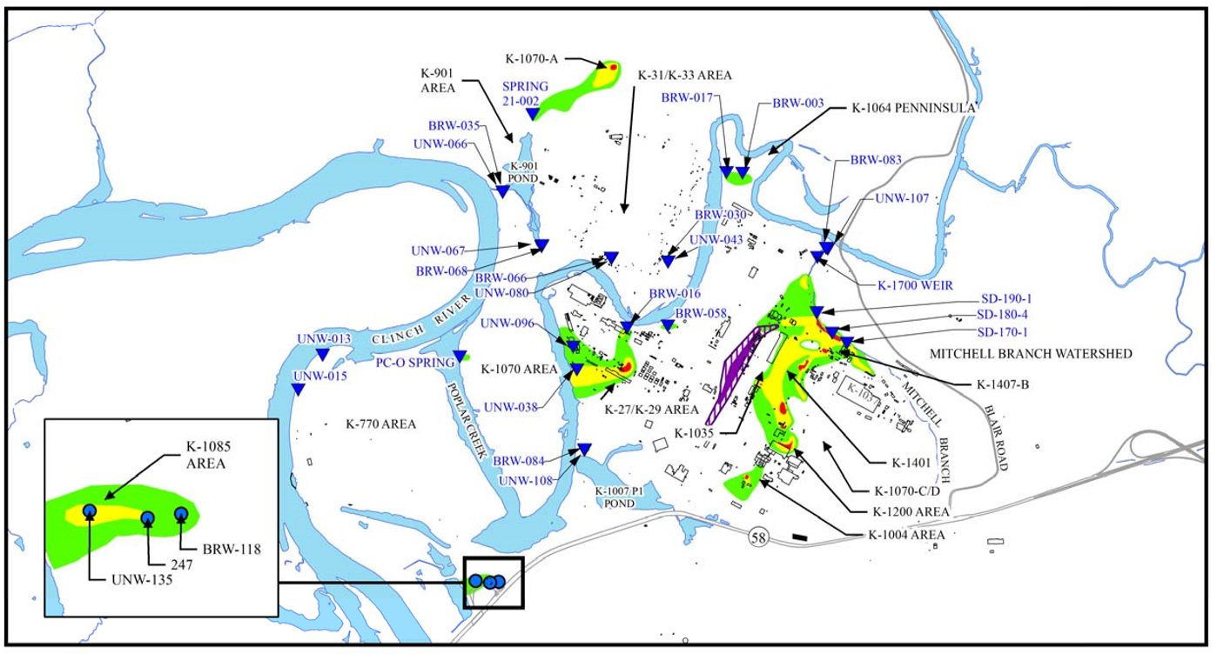
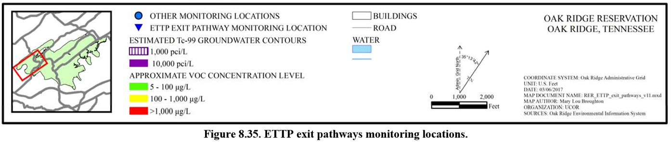
Groundwater exit pathway monitoring sites are shown in Figure 8.35 from the RER. Groundwater monitoring results and figures for the exit pathways are summarized below and are directly pulled from the RER (see reference below).

Mitchell Branch
Monitored by K-1700 Weir and wells BRW-083 and UNW-107
- Wells have been monitored since 1994
- Detection of VOCs in groundwater near the mouth of Mitchell Branch indicates the migration of the Mitchell Branch VOC plume complex.
- The intermittent detection of VOCs in this exit pathway is thought to be a reflection of variations in groundwater flow paths that can fluctuate with seasonal hydraulic head conditions which are strongly affected by rainfall
- In FY2016, no chlorinated VOCs were detected in either well.

K-1064 Peninsula Area
Monitored by wells BRW-003 and BRW-017
- Metals detected in groundwater at the site include antimony and arsenic.
- BRW-003 had an antimony detection of 0.11 µg/L and BRW-017 had 0.1 µg/L
- BRW-003 had an arsenic detection of 0.015 mg/L and BRW-017 had 0.016 mg/L
- 1,1,1-TCA was detected at 0.65 J µg/L in well BRW-003 in September but not in March
- Cis-1,2-DCE was detected in well BRW-017 at 2.1 and 1.9 µg/L in March and September, respectively
- TCE was present at concentrations less than the MCL during FY 2016 at both wells
- TCE was detected in BRW-017 at2.6 and 2.3 µg/L in March and September, respectively
- TCE was detected in BRW-003 at 0.38 J µg/L in September but not in March
- The decreasing concentrations of arsenic and VOCs in groundwater at the K-1064 Peninsula area indicate steadily improving groundwater quality
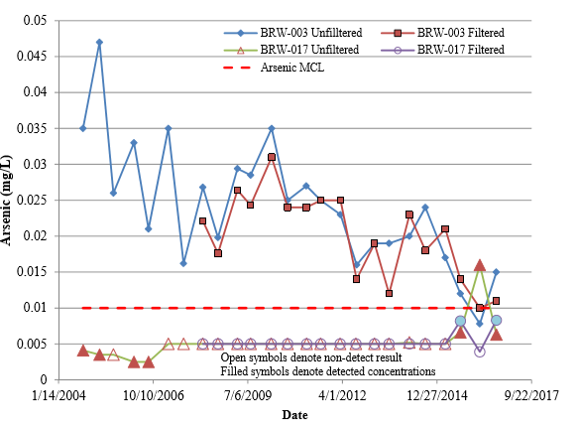
Figure 1. Arsenic concentrations in groundwater in the K-1064 Peninsula area

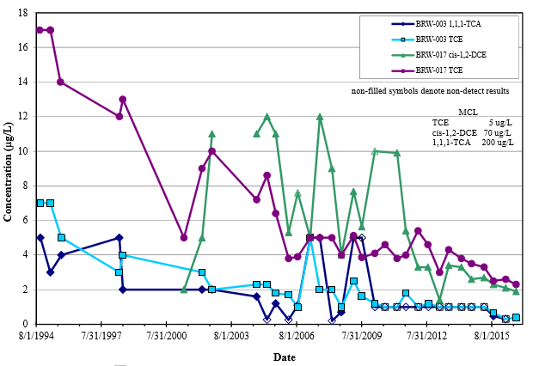
Figure 2. VOC concentrations in groundwater at K-1064 Peninsula area

K-31/K-33 Area
Monitored by wells BRW-066, BRW-030, UNW-080, and UNW-043
- Leaks of recirculated cooling water in the past have left residual subsurface chromium contamination
- UNW-043 and UNW-080 have had chromium concentrations exceeding the 0.1 mg/L MCL screening concentration in the past while levels have been much lower in the bedrock wells
- Groundwater at well UNW-043 exhibits the highest residual chromium concentrations in the area
- During FY 2016, the chromium concentration in filtered aliquots were 0.017 and 0.0056 mg/L in March and August, respectively
- During FY 2016, both field-filtered and unfiltered samples were collected for chromium analysis from UNW-080, UNW-043, and BRW-066 – UNW-043 and UNW-080 were less that the MCL and chromium was not detected in samples from BRW-066
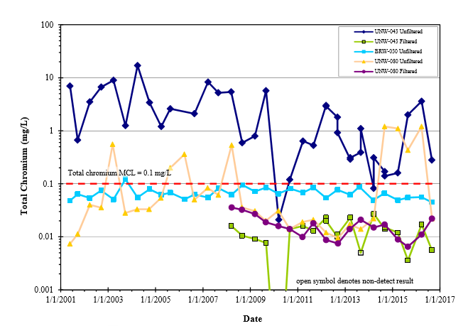
Figure 3. Chromium concentrations in groundwater in the K-31/K-33 area

K-27/K-29 Area
Monitored by wells BRW-058, BRW-016, UNW-038, and UNW-096
- The source of VOC contamination in well BRW-058 is nor suspected to be from K-27/K-29 area operations but is more likely associated with groundwater contamination that originates in the K-25 area
- BRW-058 VC continues to slightly exceed MCL while cis-1,2-DCE remains at concentrations slightly lower than the MCL. The presence of VC and cis-1,2-DCE is an indication that some natural attenuation is occurring in the source area.
- VOC concentrations in BRW-016 continue to gradually decrease and cis-1,2-DCE is the only detectable VOC, lower than its MCL.
- TCE levels in UNW-038 exhibit a long-term decreasing trend, with seasonal fluctuations (higher in wet season and lower during dry season) between about 10 to 20 times the MCL.

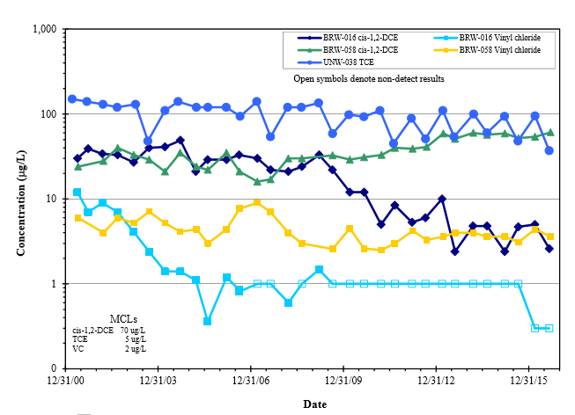

Figure 4. Detected VOC concentrations in groundwater exit pathway wells near K-27 and K-29

K-1007-P1 Holding Pond Area
Monitored by BRW-084 and UNW-108
- These wells were monitored intermittently from 1994 through 1998 and semiannually from FY 2001 through FY 2016.
- Low concentrations of TCE and cis-1,2-DCE were first detected in FY 2016. The source is not known.
- During FY 2016, no VOCs were detected in either well.
- Metals continue to be detected and are associated with the presence of turbidity in the samples.
- Data from filtered samples indicate very low, apparently dissolved concentrations of antimony ad selenium.
- Potential source of these metals in this area are unknown and the detected concentrations are far below any criterion level.

K-901-A Holding Pond Area
Monitored by BRW-035, BRW-068, UNW-066, UNW-067, Spring 21-002, and Spring PC-0
- Very low concentrations of VOCs are occasionally detected in wells adjacent to the K-901-A Holding Pond. However, these contaminants are not persistent in groundwater west and south of the pond.
- VOCs detected in the wells in FY 2016 include cis-1,2-DCE at 0.46 J µg/L and TCE at 0.31 J µg/Lin March sample from well BRW-035, and TCE at 0.48 J µg/L in the March sample from well UNW-066.
- BRW-035 alpha and beta activity have remained fairly consistent over the past several years with non-detect concentrations of alpha and beta levels between about 10 – 15 pCi/L.
- BRW-068 has experiences fairly stable, low to non-detect concentrations of alpha and less than 10 pCi/L of beta activity.
- In the past two years at well UNW-066, the alpha activity has exceeded the 15 pCi/L screening level in three of four samples, with a value of 62.5 pCi/L in August 2016. Likewise, the beta activity levels in well UNW-066 have exceeded the 50 pCi/L screening level in three of four samples collected during FY 2015 – 2016.
- During August 2016, the beta activity was 79.9 pCi/L. In well UNW-067 the alpha and beta activity screening levels were not exceeded during FY 2016. Tc-99 was analyzed in samples from wells UNW-066 and UNW-067 during FY 2016. Low concentrations of Tc-99 were detected in samples from both wells. In well UNW-066, the Tc-99 level was 8.81 pCi/L in March and, in well UNW-067, the level was 6.03 pCi/L in September.
- TCE is the most significant groundwater contaminant detected in the springs.
- Spring PC-0 was added to the sampling program in 2004. During April through October each year, spring PC-0 is submerged beneath the Watts Bar lake level. In the late winter of 2012, DOE installed a sampling pump in the spring mouth to allow year-round sampling. The contaminant source for the PC-0 spring is presumed to be disposed waste at the former Construction Spoil Area (K-1070-F) located on Duct Island. The TCE concentrations in PC-0 spring have varied between non-detectable levels and 26 µg/L and have decreased from their highest measured value in 2006 to concentrations less than or several times the drinking water standard. During FY 2016, cis-1,2-DCE was detected at estimated low concentrations <1 µg/L in PC-0 samples collected in November 2015 and in March and September 2016.
- Although TCE is the principal contaminant detected at spring 21-002, 1,1-DCE, carbon tetrachloride, chloroform, and PCE were present at concentrations less than 5 µg/L. The TCE concentration at spring 21-002 tends to vary between less than 5 and 25 µg/L and this variation appears to be related to variability in rainfall which affects groundwater discharge from the K-1070-A VOC plume. During FY 2016, the TCE detected concentrations ranged from a high of 24 µg/L detected in November 2015 to a low of 5.4 µg/L in March 2016. Alpha activity was detected at 3.13 and 4.09 pCi/L in November and March samples, respectively, and detected beta activities were 20.8 and 9.08 pCi/L in November and May samples, respectively. Tc-99 detections ranged from 2.71 to 19.9 pCi/L. which are much lower than the 900 pCi/L MCL-DC. U-234, U-235, and U-238 were detected at less than 1 pCi/L.

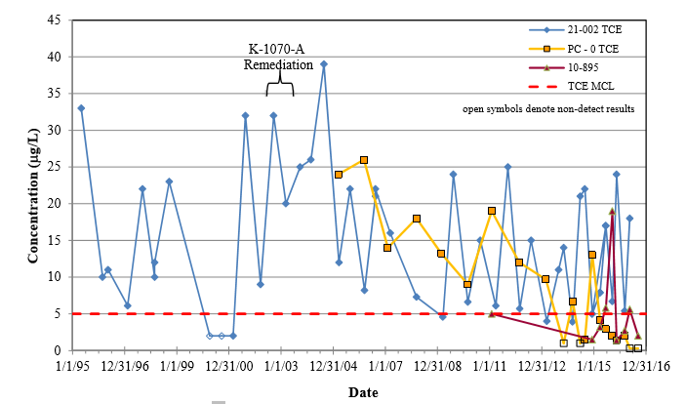

Figure 5. TCE concentrations in selected ETTP area springs

K-770 Area
Monitored by UNW-013 and UNW-015
- Measured alpha and beta activity levels were below screening levels during FY2016, with the exception that beta activity in the September 2016 sample well UNW-013 had 50.8 pCi/L (50 pCi/L is the beta activity screening level).
- Historic analytical results indicate that the alpha activity is largely attributable to uranium isotopes, and well UNW-013 historically contained Tc-99 that is a strong beta-emitting radionuclide responsible for the elevated beta activity in that well. Much lower alpha and beta activity levels have been measured in well UNW-015 since sampling was resumed in FY 2013 following an interruption in sampling during site remediation activities.

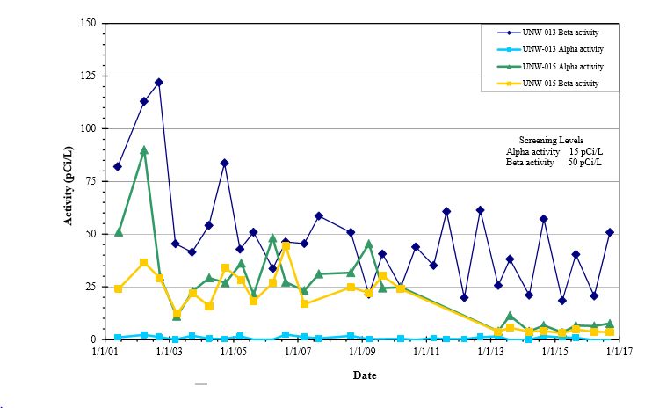
Figure 6. History of measured alpha and beta activity in the K-770 area

K-1085 Drum Burial/Old Firehouse Burn Area
Monitored by BRW-118, UNW-135, and surface seep location 247
- In October 2000, the TDOT encountered three buried drums adjacent to TN Highway 58 during a road widening project. This discovery triggered a CERCLA Removal Action to identify buried waste at the site and to excavate and dispose of the waste at the EMWMF. Approximately 77 m3 of mixed RCRA, Toxic Substances Control Act of 1976, and LLW was excavated from five separate locations at the 12,000 ft2 site. In 2005, the area was further characterized, and in 2008 an additional 300 yd3 of soil were removed for disposal.
- Wells BRW-118 and UNW-135 are sampled semiannually to provide contaminant trend data.
- In well BRW-118 PCE and TCE both exceed their 5 µg/L MCL screening levels and both exhibit seasonal fluctuations. The detected concentrations of cis-1,2-DCE, carbon tetrachloride, and chloroform in well BRW-118, are all less than MCL screening levels.
- At well UNW-135, TCE continually exceeds its 5 mg/L MCL screening level, although cis-1,2-DCE concentrations dipped below its 70 µg/L MCL screening level between March 2014 and March 2016, with the most recent point reaching 85 µg/L. The measured VOC concentrations at the site are indicative of dissolved phase contamination in the groundwater.
- Concentration trends at the K-1085 site are generally decreasing although concentrations fluctuate based on seasonal influences.

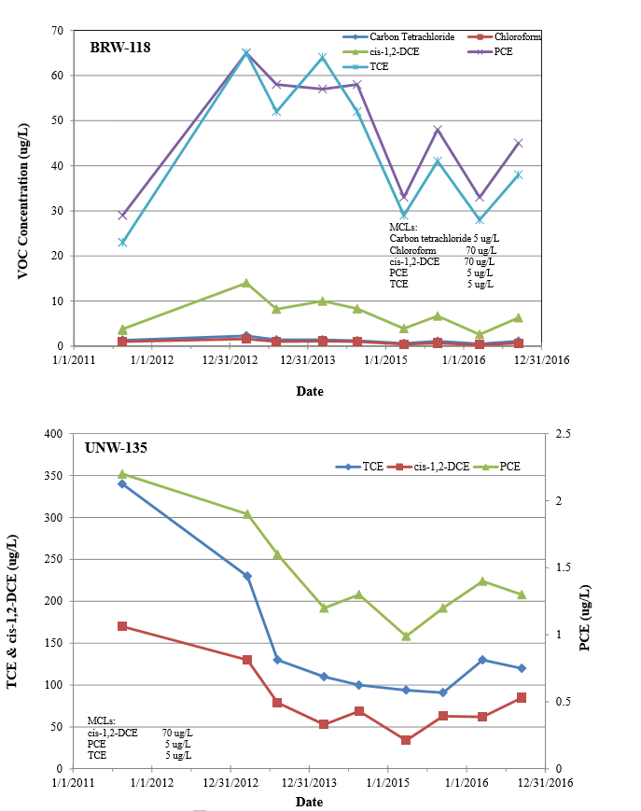
Figure 7. VOC concentrations in groundwater at K-1085

Reference
2017 Remediation Effectiveness Report for the U.S. Department of Energy Oak Ridge Reservation Oak Ridge, Tennessee file:///E:/2017%20Remediation%20Effectiveness%20Report%20for%20DOE%20ORR.pdf

